Norfolk County Council proposes to make a Temporary Traffic Regulation Order (the “Order”) (STRO11867) affecting the U71621 Newmarket Road from its junction with C645 Roundhouse Way for 445m eastwards (the “Road”) in the Parish of Cringleford to facilitate installation of new dropped kerb, the Road will be temporarily closed (except for pedestrian access) for the duration of the works/period the closure is necessary which is anticipated to be from 6th to 10th January 2025, but may continue to be closed until the 21st February 2025 where the closure is still required beyond the anticipated dates.

Alternative route is via: N/A.

NB: Please note that access will be maintained at all times to permit traffic on U71621 Newmarket Road to their final destination.

Vehicular access will be permitted to a final destination in the Road where signs indicating such access is possible and permitted are in place.

The Order shall automatically revoke on the completion of the works when the closure is no longer necessary or otherwise on the 21st February 2025 without further notice.

If necessary, the restriction could run for a maximum period of 18 months from the date the Order is effective.

A person who contravenes, or who uses or permits the use of a vehicle in contravention of the closure imposed by the Order shall be guilty of an offence.

Penalty: £1000 maximum fine on conviction and/or endorsement for contravention.

In the event of the start date being delayed the new start date will be displayed on site in advance.

Full details on the closure are available at https://one.network. Any enquiries that cannot be answered on the one.network website should be directed to the South Area Streetworks (Community and Environmental Services Department) contactable by telephone at 0344 800 8020 or email at streetworks@norfolk.gov.uk

Dated this 27th day of December 2024.

Katrina Hulatt
Director of Legal Services (nplaw)
County Hall
Martineau Lane
Norwich
NR1 2DH

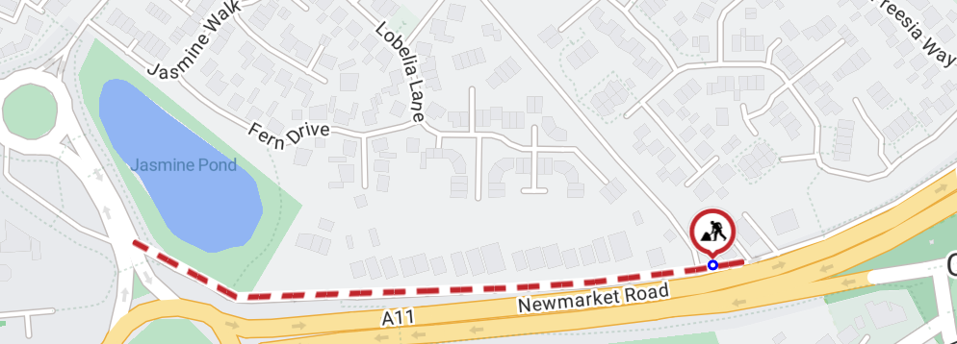
Imagery © 2024 maptiler | imagery © 2024 hexagon | © maptiler © openstreetmap contributors

